**For already cloned code Visual Studio 2019 Community**

1. Log in to you github on VS2019. Clone the project, be careful clone the whole project that includes (Chapter12, Stroustrup_Graphics, and other files).
2. Clone repository and open. If you cant see files of your project go to Widok -> Ekplorator rozwiazan
3. Unzip fltk-1.1.10-source.zip
4. Run fltk-1.1.10 ->visualc ->fltk.dsw. Important wait until it ends and then build a project that was open by fltk.dsw. Without building the project you won’t get needed files to FLTK folder. Do not worry about errors after the build.
5. Close Visual studio
6. Here is the change from VS 2015! Copy all files from fltk-1.1.10\lib folder apart from README.lib to C:\Program Files (x86)\Microsoft Visual Studio\2019\Community\VC\Auxiliary\VS\lib\x64

And

C:\Program Files (x86)\Microsoft Visual Studio\2019\Community\VC\Auxiliary\VS\lib\x86

1. Copy FL folder to C:\Program Files (x86)\Microsoft Visual Studio\2019\Community\VC\Auxiliary\VS\include
2. Open Visual Studio and make sure you see files from Stroustrup_Graphics.sln view. To be sure double click on this file in VS. Or in explorator panel on the top click Przełacz widoki -> Stroustrup_Graphics.sln

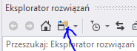

1. Right-click on the project name (the second from the bottom on list, Stroustrup_Graphics) then Properties (Właściwości) -> Linker (Konsolidator) ->Input (dane wejściowe) and pate the following at the beginning with colons

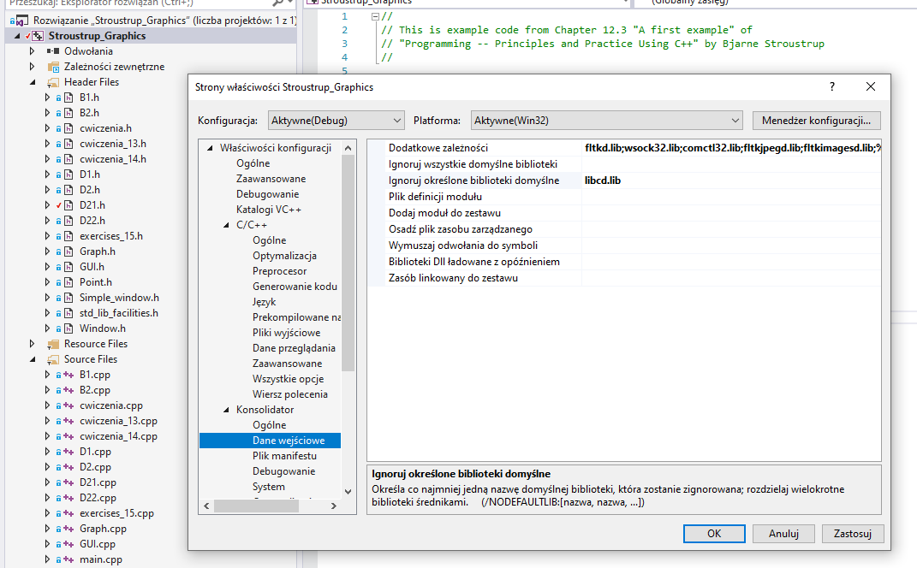

fltkd.lib;wsock32.lib;comctl32.lib;fltkjpegd.lib;fltkimagesd.lib;

1. In a field ignore specific library (Ignoruj określone biblioteki domyślne) make sure there is libcd.lib
2. In Properties -> C/C++->Code generation (generowanie kodu) -> Runtime library (Biblioteka środowiska uruchomieniowego) make sure there is Multi-threaded Debug DLL (/MDd) (Wielowątkowe debugowanie biblioteki DLL (/MDd) )
3. Run using x86 Debug mode (depends on your Visual Studio most likely)
4. Now it should work